

American International University- Bangladesh

Computer Networks

Final Term Assignment

Spring 2022-23

**Name :** Shanto Kumar Basak

**ID** : 20-42945-1

**Section:** L

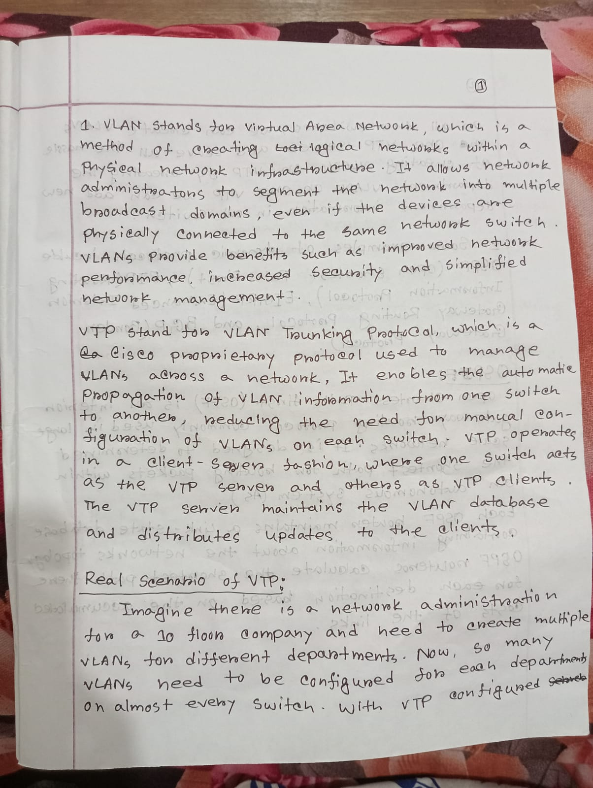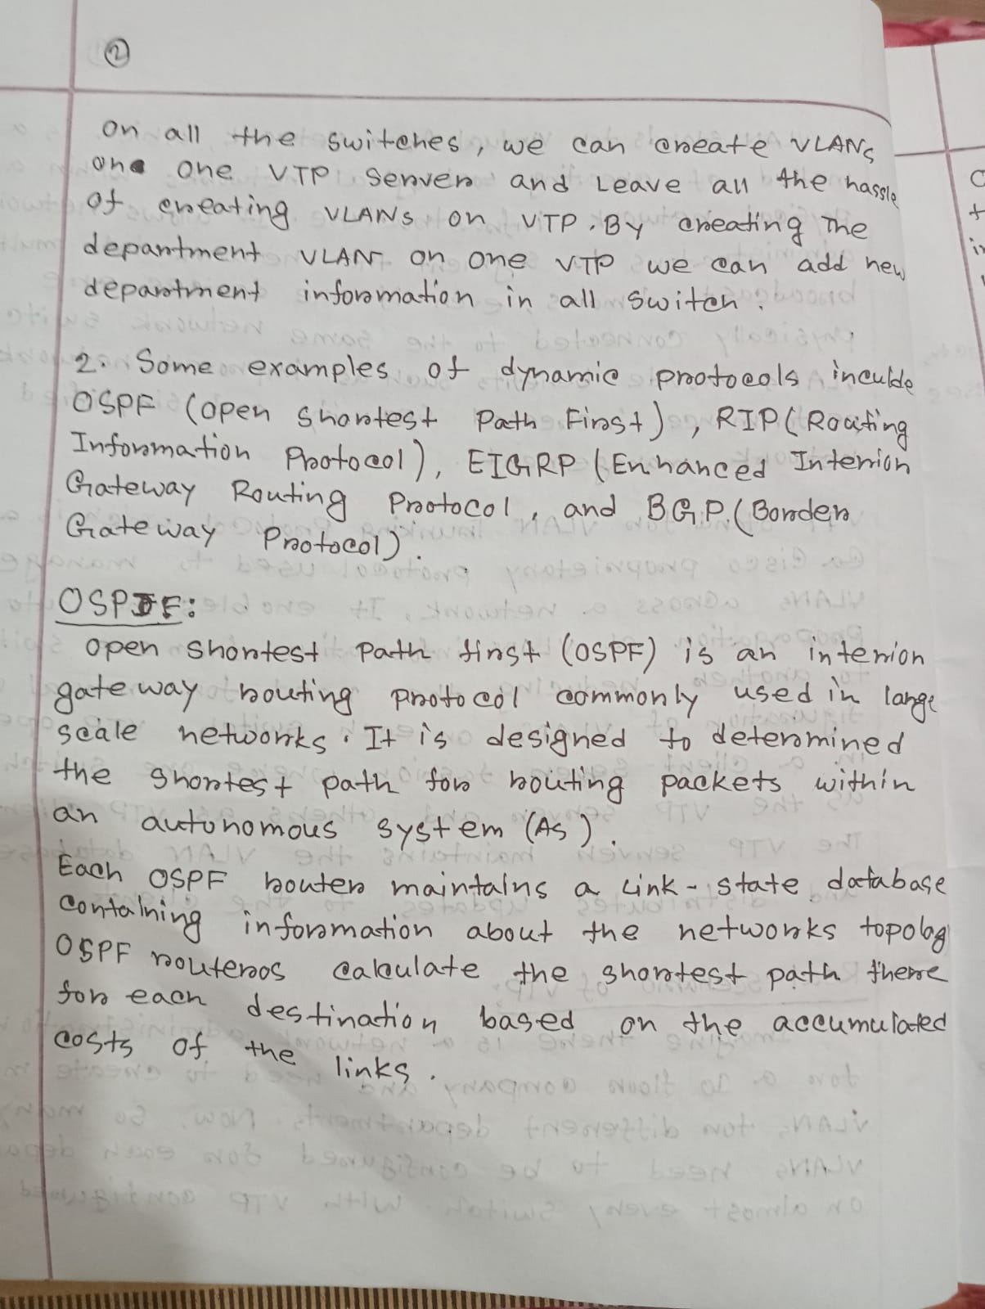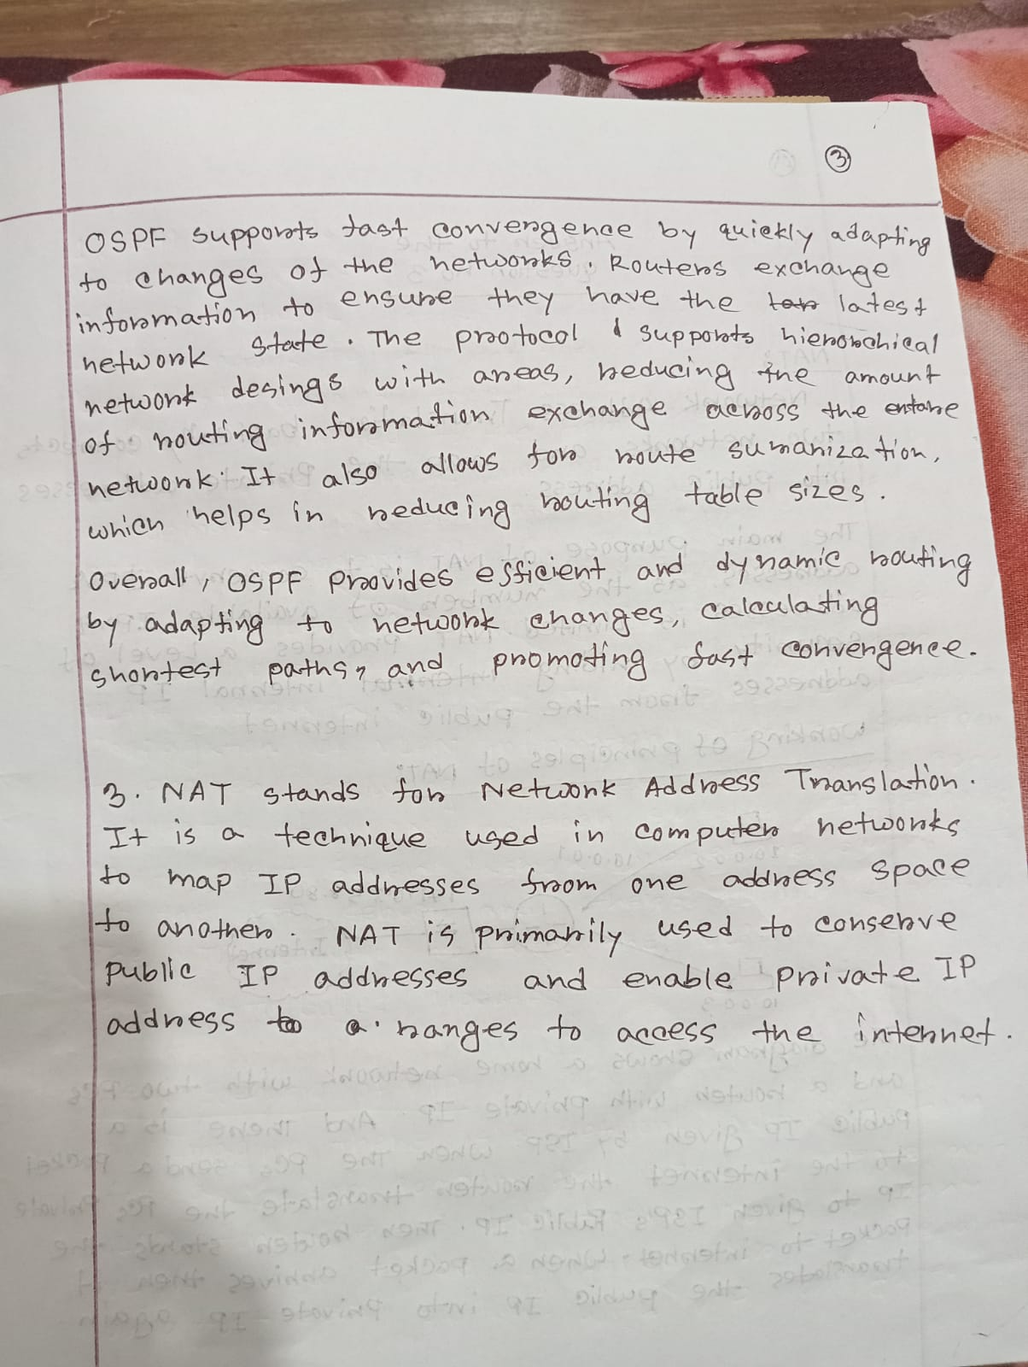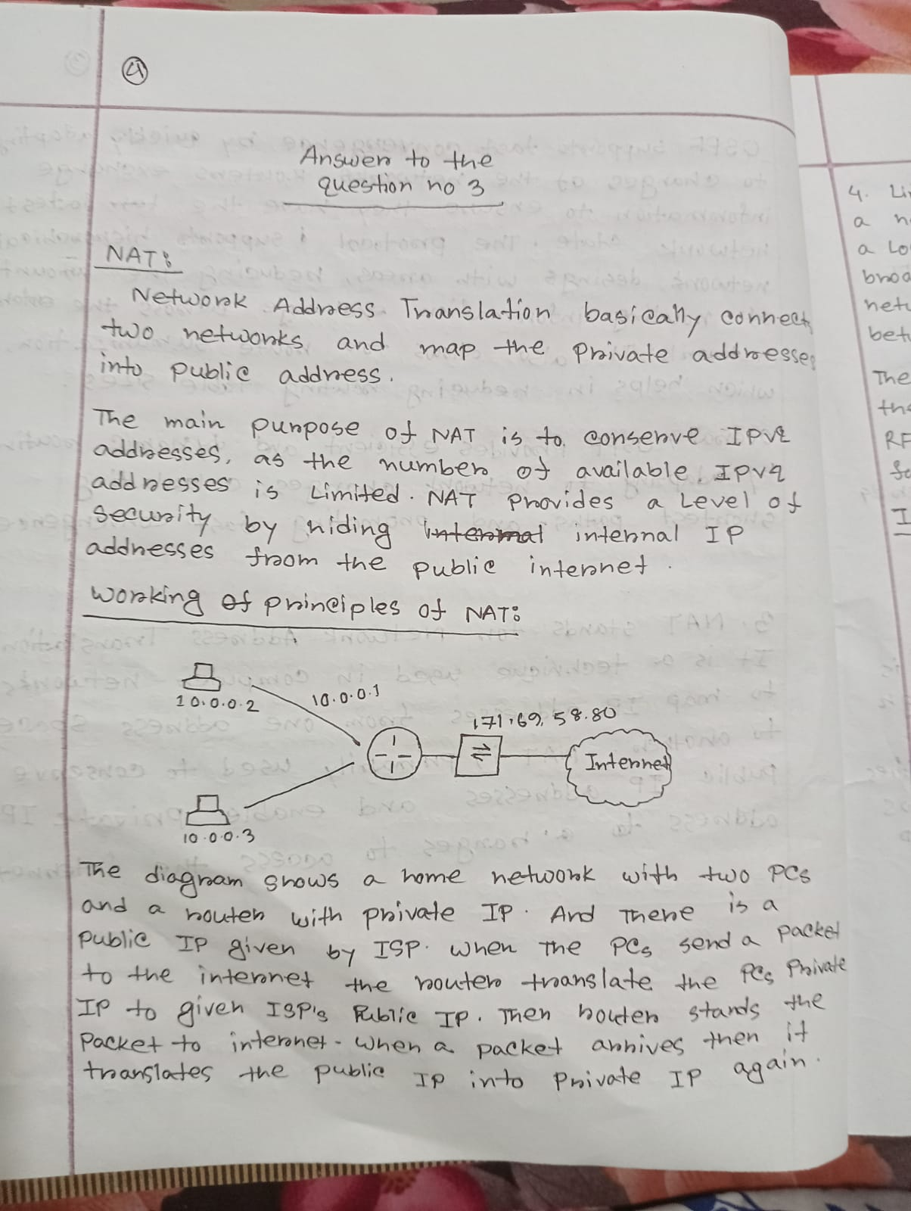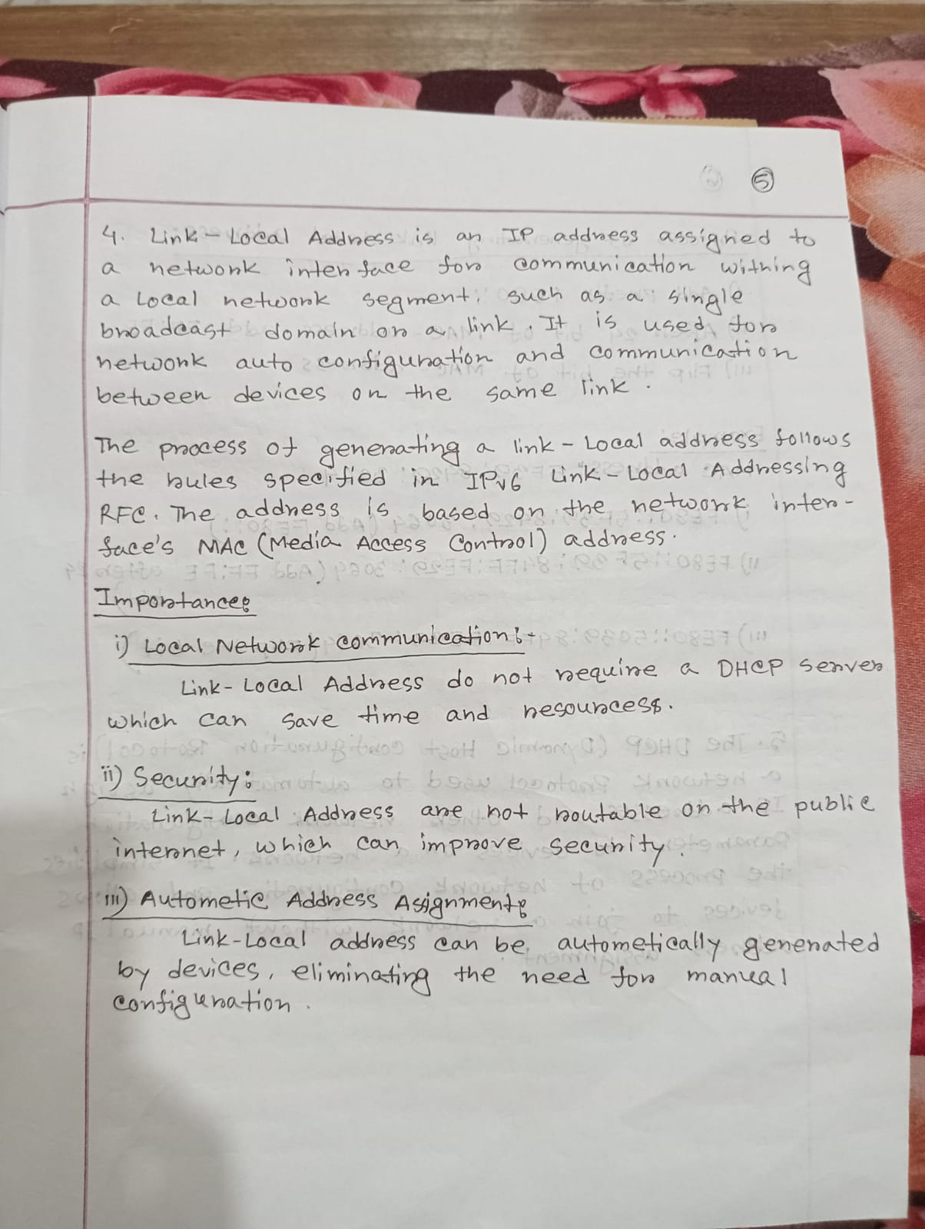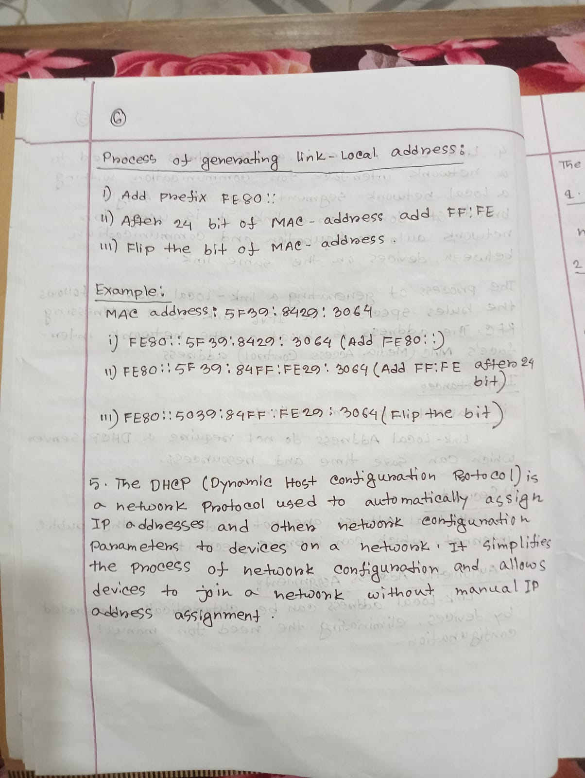

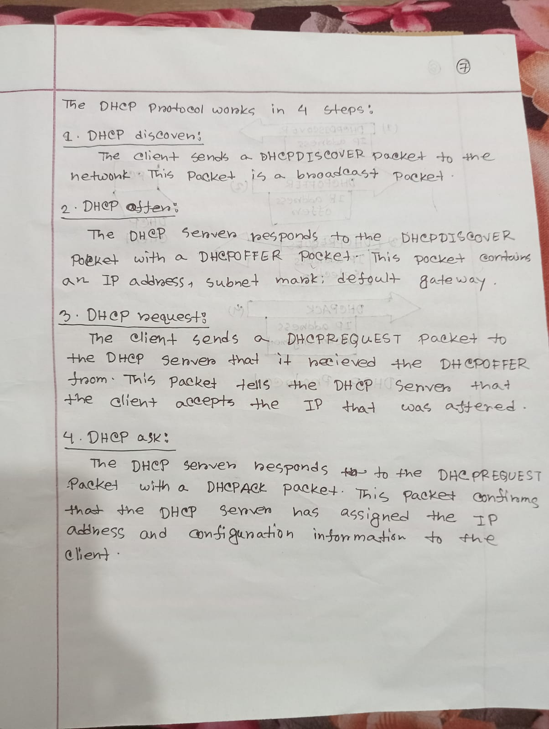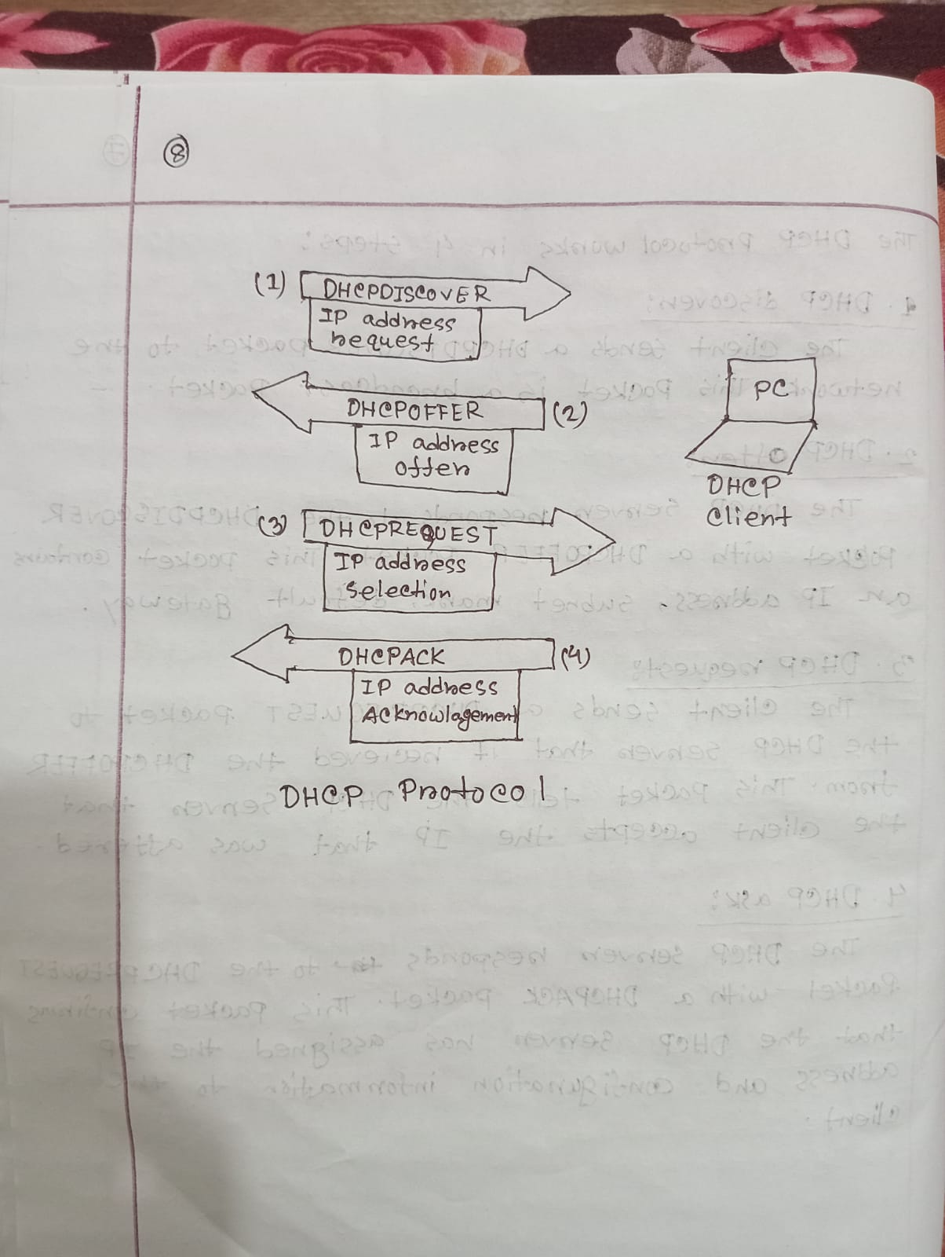

**Answer to the Question No 6 :**

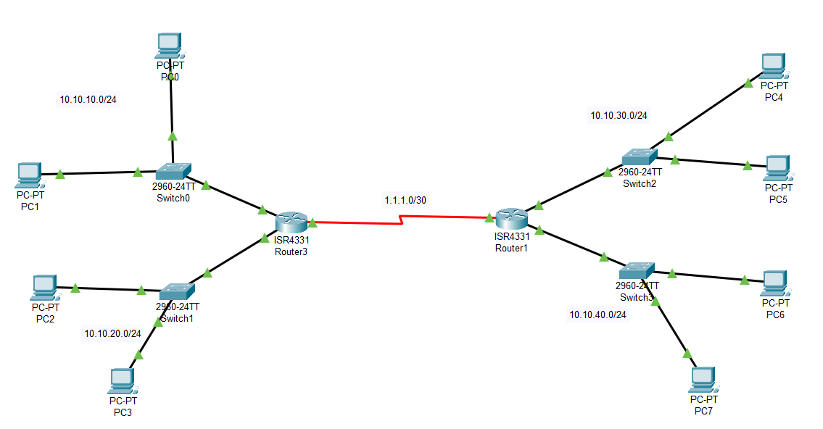

Mon May 22 15:00:05 2023 Router0 Router>en

Mon May 22 15:00:08 2023 Router0 Router#conf t

Mon May 22 15:00:20 2023 Router0 Router(config)#int gig0/0/0

Mon May 22 15:00:49 2023 Router0 Router(config-if)#ip add 10.10.10.254 255.255.255.0

Mon May 22 15:00:55 2023 Router0 Router(config-if)#exit

Mon May 22 15:01:17 2023 Router0 Router(config)#int gig0/0/1

Mon May 22 15:01:46 2023 Router0 Router(config-if)#ip add 10.10.20.254 255.255.255.0

Mon May 22 15:02:50 2023 Router0 Router(config-if)#exit

Mon May 22 15:03:03 2023 Router0 Router(config)#int gig0/0/0

Mon May 22 15:03:10 2023 Router0 Router(config-if)#no shutdown

Mon May 22 15:03:17 2023 Router0 Router(config-if)#exit

Mon May 22 15:03:25 2023 Router0 Router(config)#int gig0/0/1

Mon May 22 15:03:31 2023 Router0 Router(config-if)#no shutdown

Mon May 22 15:04:53 2023 Router0 Router(config-if)#exit

Mon May 22 15:12:02 2023 Router1 Router>en

Mon May 22 15:12:05 2023 Router1 Router#conf t

Mon May 22 15:12:33 2023 Router1 Router(config)#int gig0/0/0

Mon May 22 15:17:23 2023 Router1 Router(config-if)#ip add 10.10.30.1 255.255.255.0

Mon May 22 15:17:40 2023 Router1 Router(config-if)#int gig0/0/1

Mon May 22 15:18:09 2023 Router1 Router(config-if)#ip add 10.10.40.1 255.255.255.0

Mon May 22 15:18:36 2023 Router1 Router(config-if)#no shut

Mon May 22 15:18:43 2023 Router1 Router(config-if)#exit

Mon May 22 15:18:50 2023 Router1 Router(config)#int gig0/0/0

Mon May 22 15:18:54 2023 Router1 Router(config-if)#no shut

Mon May 22 15:17:32 2023 Router0 Router>en

Mon May 22 15:17:38 2023 Router0 Router#cof t

Mon May 22 15:17:44 2023 Router0 Router#conf t

Mon May 22 15:20:41 2023 Router0 Router(config)#router eigrp 10

Mon May 22 15:21:17 2023 Router0 Router(config-router)#network 10.10.10.0 0.0.0.255

Mon May 22 15:21:43 2023 Router0 Router(config-router)#network 10.10.20.0 0.0.0.255

Mon May 22 15:21:57 2023 Router0 Router(config-router)#no auto-summary

Mon May 22 15:22:26 2023 Router1 Router(config-if)#exit

Mon May 22 15:22:47 2023 Router1 Router(config)#router eigrp 10

Mon May 22 15:23:24 2023 Router1 Router(config-router)#network 10.10.30.0 0.0.0.255

Mon May 22 15:23:42 2023 Router1 Router(config-router)#network 10.10.40.0 0.0.0.255

Mon May 22 15:23:51 2023 Router1 Router(config-router)#no auto-summary

Mon May 22 15:24:55 2023 Router0 Router(config-router)#exit

Mon May 22 15:25:14 2023 Router0 Router(config)#int se0/1/0

Mon May 22 15:25:40 2023 Router0 Router(config-if)#ip add 1.1.1.1 255.255.255.252

Mon May 22 15:25:53 2023 Router0 Router(config-if)#no shut

Mon May 22 15:26:58 2023 Router1 Router(config-router)#exit

Mon May 22 15:27:18 2023 Router1 Router(config)#int se0/1/0

Mon May 22 15:27:49 2023 Router1 Router(config-if)#ip add 1.1.1.2 255.255.255.252

Mon May 22 15:27:55 2023 Router1 Router(config-if)#no shut

Mon May 22 15:29:45 2023 Router1 Router(config-if)#exit

Mon May 22 15:30:04 2023 Router1 Router(config)#router eigrp 10

Mon May 22 15:30:36 2023 Router1 Router(config-router)#network 1.1.1.0 0.0.03

Mon May 22 15:30:58 2023 Router1 Router(config-router)#network 1.1.1.0 0.0.0.3

Mon May 22 15:31:17 2023 Router0 Router(config-if)#exit

Mon May 22 15:31:29 2023 Router0 Router(config)#router eigrp 10

Mon May 22 15:31:49 2023 Router0 Router(config-router)#network 1.1.1.0 0.0.0.3

Mon May 22 15:33:00 2023 Switch0 Switch>enable

Mon May 22 15:33:00 2023 Switch0 Switch#configure terminal

Mon May 22 15:33:00 2023 Switch0 Switch(config)#interface FastEthernet0/1

Mon May 22 15:41:07 2023 Router1 Router(config-router)#exit

Mon May 22 15:41:17 2023 Router1 Router(config)#int gig0/0/0

Mon May 22 15:42:01 2023 Router1 Router(config-if)#ip add 10.10.30.254 255.255.255.0

Mon May 22 15:42:07 2023 Router1 Router(config-if)#no shut

Mon May 22 15:42:12 2023 Router1 Router(config-if)#exit

Mon May 22 15:42:21 2023 Router1 Router(config)#int gig0/0/1

Mon May 22 15:42:41 2023 Router1 Router(config-if)#ip add 10.10.40.254 255.255.255.0

Mon May 22 15:42:46 2023 Router1 Router(config-if)#no shut

Mon May 22 17:41:33 2023 Router3 Router>en

Mon May 22 17:41:38 2023 Router3 Router#config t

Mon May 22 17:41:56 2023 Router3 Router(config)#int gig0/0/0

Mon May 22 17:42:25 2023 Router3 Router(config-if)#ip add 10.10.10.254 255.255.255.0

Mon May 22 17:42:36 2023 Router3 Router(config-if)#no shutdown

Mon May 22 17:42:44 2023 Router3 Router(config-if)#exit

Mon May 22 17:43:07 2023 Router3 Router(config)#int gig0/0/1

Mon May 22 17:43:40 2023 Router3 Router(config-if)#ip add 10.10.10.254 255.255.255.0

Mon May 22 17:44:29 2023 Router1 Router>en

Mon May 22 17:44:34 2023 Router1 Router#config t

Mon May 22 17:45:09 2023 Router1 Router(config)#int gig0/0/0

Mon May 22 17:50:11 2023 Router1 Router(config-if)#ip add 10.10.30.254 255.255.255.0

Mon May 22 17:50:15 2023 Router1 Router(config-if)#no shutdown

Mon May 22 17:50:17 2023 Router1 Router(config-if)#exit

Mon May 22 17:50:32 2023 Router1 Router(config)#int gig0/0/1

Mon May 22 17:51:23 2023 Router1 Router(config-if)#ip add 10.10.40.254 255.255.255.0

Mon May 22 17:51:32 2023 Router1 Router(config-if)#no shutdown

Mon May 22 17:51:48 2023 Router3 Router(config-if)#int gig0/0/1

Mon May 22 17:52:08 2023 Router3 Router(config-if)#ip add 10.10.20.254 255.255.255.0

Mon May 22 17:52:15 2023 Router3 Router(config-if)#no shutdown

Mon May 22 17:52:29 2023 Router3 Router(config-if)#exit

Mon May 22 17:52:40 2023 Router3 Router(config)#router eigrp 10

Mon May 22 17:53:12 2023 Router3 Router(config-router)#network 10.10.10.0 0.0.0.255

Mon May 22 17:53:38 2023 Router3 Router(config-router)#network 10.10.20.0 0.0.0.255

Mon May 22 17:53:51 2023 Router3 Router(config-router)#no auto-summary

Mon May 22 17:53:54 2023 Router3 Router(config-router)#exit

Mon May 22 17:56:17 2023 Router3 Router(config)#int se0/1/0

Mon May 22 17:56:49 2023 Router3 Router(config-if)#ip add 1.1.1.1 255.255.255.252

Mon May 22 17:56:55 2023 Router3 Router(config-if)#no shutdown

Mon May 22 17:57:20 2023 Router1 Router(config-if)#exit

Mon May 22 17:58:09 2023 Router1 Router(config)#int se0/1/0

Mon May 22 17:58:34 2023 Router1 Router(config-if)#ip add 1.1.1.2 255.255.255.252

Mon May 22 17:58:44 2023 Router1 Router(config-if)#no shutdown

Mon May 22 17:58:54 2023 Router1 Router(config-if)#exit

Mon May 22 17:59:07 2023 Router1 Router(config)#router eigrp 10

Mon May 22 17:59:28 2023 Router1 Router(config-router)#network 1.1.1.0 0.0.0.3

Mon May 22 18:00:40 2023 Router3 Router(config-if)#exit

Mon May 22 18:00:45 2023 Router3 Router(config)#router eigrp 10

Mon May 22 18:01:05 2023 Router3 Router(config-router)#network 1.1.1.0 0.0.0.3